**Test Document for Generate log and email alert if previous version of Item is not expired on DCR approval.**

Testing in DCR Number - BOI000224

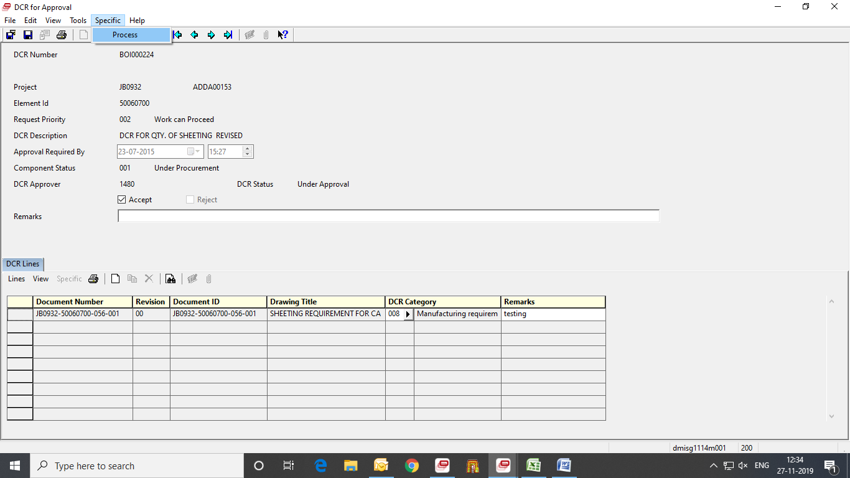

After click of Process button, log should be generated when item-wise and document-wise status is not expired.

With the help of debugger, we just stop the process before the after.choice.

Change the status of dmisg001.stat by help of GTM.

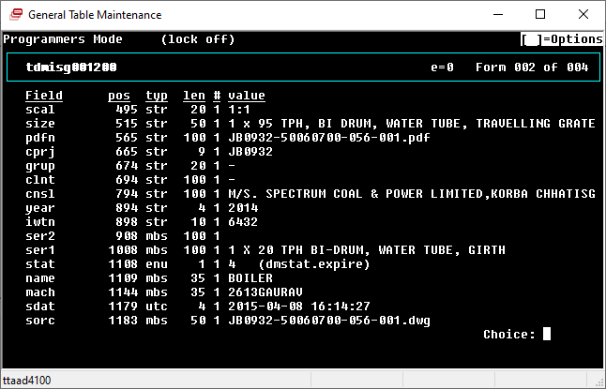

After changing status,

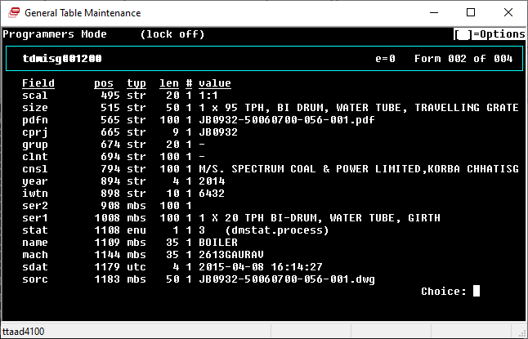

Similarly, Change the status for Item Wise table i.e., dmisg005.stat

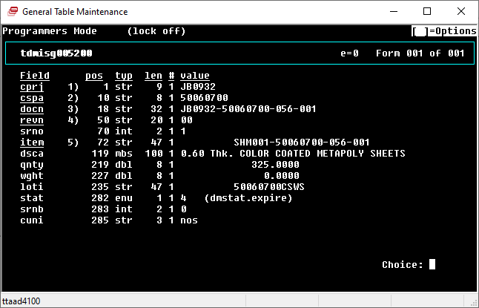

After changing status,

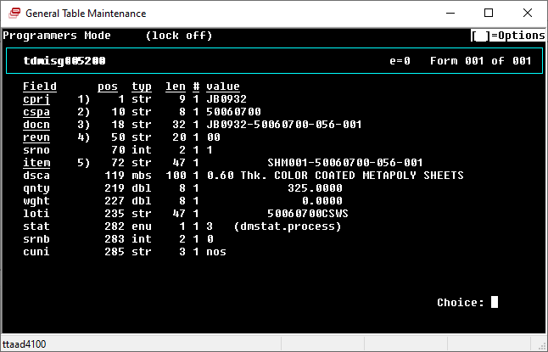

Then continue the debugger, to generate the log into tables:

Dmisg116 – Document Wise log table

Dmisg117 – Item Wise log table.

After that send the email alert.

**Results:**

1. Log generated for Documents Wise.

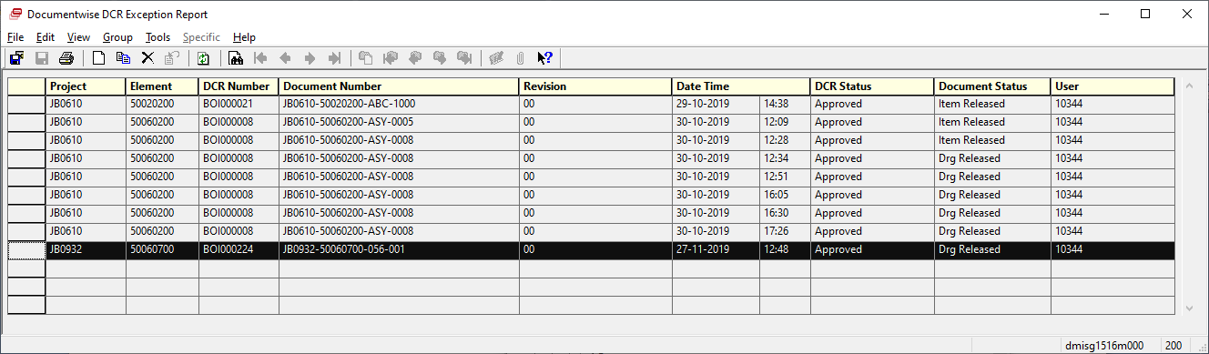

1. Log generated for Item Wise.

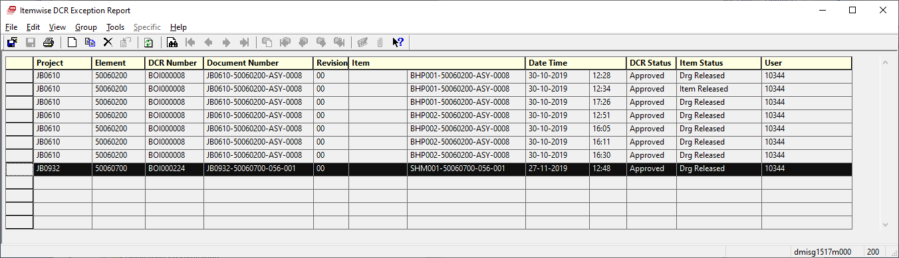

1. Email alert

